Study of the effect of sample pressure on in situ BTEX chromatographs
Cristina Romero Triguerosª, Marta Doval Miñarro^{b,}*, Esther González Duperónª, Francisco José Marzal Martínez^{c}, Enrique González Ferradásª
ª Chemical Engineering Department, School of Chemistry, University of Murcia, 30071, Murcia, Spain
^{b} Chemical and Environmental Engineering Department, Technical University of Cartagena, Paseo Alfonso XIII, no. 52, 30203 Cartagena, Murcia, Spain
^{c} Thermal and Fluid Engineering Department, Technical University of Cartagena, Paseo Alfonso XIII, no. 52, 30203 Cartagena, Murcia, Spain
*Corresponding author: email: marta.doval@upct.es, phone: 0034 968 325552

Abstract
In this paper, the influence of sample pressure on benzene measurements obtained with two automated in situ gas chromatograps is studied. The analysers were calibrated using a non-linear regression at 293 ± 1 K and 101.3 ± 0.2 kPa. A gas mixture of benzene in air (5 µg/m³) was produced and measured at calibration conditions. Subsequently, the sample pressure was changed to 80 and 110 kPa. Differences in readings were observed even though the pressure compensators were on, indicating incorrect performance of this tool. Further tests with two different benzene in air mixtures (5 and 40 µg/m³) at 80, 90, 105 and 110 kPa were also carried out. Results showed that the analysers take air from one or several unidentified inlets (apart from the sampling port) when the sampling pressure is lower than the atmospheric one. This is usually the case in air monitoring stations, so this phenomenon is particularly important as systematic biases could be affecting air quality data.

Keywords: air monitoring, data quality, sample pressure, benzene, chromatography

1. Introduction
Benzene is one the species regulated in air quality in Europe due to its harmful effects on human health (EC Directive 2008). It is a well-known carcinogen (Savitz and Andrews 1997) but it can also lead to non-cancerous health effects associated with dysfunctions of vital systems in the body such as the reproductive, immune, nervous, endocrine, cardiovascular and respiratory systems (Bahadar et al. 2014).
Benzene is found both in industrial and urban areas worldwide (Andreoli et al. 2015). It is used as an intermediate in chemical industries and it is present in gasoline and tobacco smoke (Darrall et al. 1998). Its mixing ratios range from few pg/m³ in rural locations to a few µg/m³ in urban ones with mean values generally below 10 µg/m³ (Baker et al. 2008; Bono et al. 2003; Fernández Somoano et al. 2011; Ferradás et al. 2010; Jaimes-Palomera et al. 2016). Its annual limit value in ambient air is set to 5 µg/m³ at 293 K and 101.3 kPa (EC Directive, 2008).
The reference method for the measurement of benzene in air is that described in parts 1, 2 and 3 of EN 14662 (2005), ‘Ambient air quality. Standard method for measurement of benzene concentrations’. Part 1 deals with pumped sampling followed by thermal desorption and gas chromatography, Part 2 with pumped sampling followed by sorbent desorption and gas chromatography and Part 3 with automated pumped sampling with in situ gas chromatography. Whereas Parts 1 and 2 involve sampling in the field and subsequent analysis in the laboratory, Part 3 describes a method for both sampling and analysis on site. The advantage of analysing samples in the lab is that bench-top chromatographs are used and they can provide superior discrimination capabilities with excellent precision, sensitivity and reproducibility (Ho et al. 2001). However, this equipment is very expensive and requires trained staff to operate it. Moreover, samples have to be collected, transported and stored and, thus, sample composition may change due to the adsorption of components to the walls of the sample vessel, evaporation of benzene, degradation by microbial activity, oxidation or other reactions (Kotiaho 1996). In situ gas chromatographs offer good analytical performance and the possibility of carrying out real-time measurements and long-term remote monitoring. They are less expensive than bench-top gas chromatographs and their operation is very straightforward. When used in air monitoring stations, they must be type-approved, that is, they must comply with the criteria of the performance tests described in standard EN 14662-3:2015.
Automatic in situ BTEX (benzene, toluene, ethylbenzene and xylenes) chromatographs have been used in different works to assess air quality (Palmgren et al. 1999; Parra et al. 2009; Wang et al. 2010). They have also been intercompared to other measurement techniques in the field (Villanueva et al. 2012; Wideqvist et al. 2003), being selected as the reference method for analysis of benzene and toluene in the latter work.
However, the response of automatic in situ BTEX chromatographs to changes in environmental variables such as pressure or temperature has been very little studied, with the result that final users of this equipment are highly uninformed regarding the influence on measurements of these variables.
In this work, we systematically analyse the influence of changes in sample pressure on benzene measurements obtained with a commercial automatic in situ BTEX analyser, widely used both in air quality monitoring networks and in air pollution studies. Changes in sample pressure can occur because of variations in atmospheric pressure and operational differences between calibration and routine measurements (Doval Miñarro et al. 2011). Thus, during calibration in situ by means of pressurised gas cylinders, some overpressuring of the system can occur, despite using a safe vent. When analysers are measuring ambient air, a certain pressure drop, below the atmospheric one, is produced in the sampling line. If, in addition, the sampling line maintenance is not adequate, this pressure drop will increase. Furthermore, because the equipment installed in air quality monitoring stations is often connected to manifolds and may have different sucking flow rates, the connection or disconnection of one or more of them can affect the sample pressure of the rest of them. All of this can bring about pressure differences between calibration and sampling from several tenths to tens of kPa (Doval Miñarro et al. 2011).
The aim of this work is to make the users of these analysers aware of the influence that variations of sample pressure have on readings so that precautions can be taken when calibrating and measuring in order to attain lower measurement uncertainties. Although benzene is the only specie studied in this work, the results may be also extrapolated to ethylbenzene, toluene and xylenes measurements if obtained with this analytical method.

2. Materials and methods
2.1. Experimental set-up
The influence of sample pressure was studied with two identical type-approved on-site BTEX Syntech Spectras GC955 chromatographs (Groningen, The Netherlands), named analysers I and II. The air sample is forced through a built-in preconcentration system. Hydrocarbons are preconcentrated on Tenax GR, thermically desorbed and separated on an AT-5 capillary column (15 m length × 0.32 mm i.d. × 1 µm HELIFLEX coating). Analysis is done by a photo ionisation detector (PID). The two analysers are preconfigured to identify as benzene the signals detected by the PID in the windows 176–212 s and 148–182 s, respectively. Each measurement cycle lasts for 15 min. The process is semi-continuous. While the analyser is analysing a sample, a new one is been sampled and sent to the preconcentration system. The sampling system draws 35 ml of sample to the Tenax column, and this is repeated five times, which means that a total volume of 175 ml is analysed in each cycle. The initial oven temperature was set to 50 ºC and maintain during 3 min, then changed to 70 ºC at 10 ºC/min and kept at this temperature for 7 min; then was reduced again to 50 ºC at -10 ºC/min. Nitrogen 5.0 was used as carrier gas. According to the manufacturer, the lowest detection limit is 0.1 µg/m³ and the repeatability < 3%. The short term drift at the span value was measured in 24 hours and turned out to be < 5%.
A dynamic dilution system was used for the generation of known concentrations of benzene in zero air. Zero air was pressurised ambient air subjected to a purification step with active charcoal. A high concentration mixture of benzene in nitrogen (1000 µg/m³ nominal concentration) from a gas cylinder was mixed with the zero air to attain the experimental concentrations required. The flow of both gases was controlled and measured with Bronkhorst mass flow controllers (0–0.4 l/min range for the benzene in nitrogen mixture, and 0–12 l/min for the zero air). The whole piping system was set up inside a thermally controlled chamber. Atmospheric pressure was measured by means of a THIES mercury barometer. Changes in pressure were produced by changing the status of valves V1 and V2 in Figure 1 and measured, relative to the atmospheric pressure, with Magnehelic® differential pressure gauges (P.I.). The experiments were divided into two sets. For the first one, the described facility was used. For the second one, a homemade stainless steel chamber was added to the system to isolate the analyser from the environment of the rest of the laboratory in terms of concentration and pressure, so that the analyser was surrounded by air containing the same amount fraction of benzene as the air sampled by the analyser from the dynamic system at the reference pressure (Figure 2).

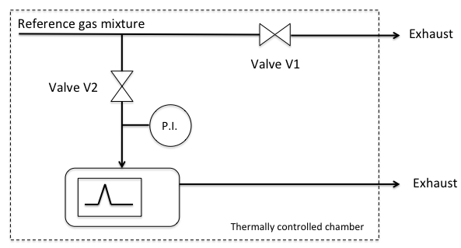
Figure 1. Schematic of the set-up used in the first set of experiments. Sample pressure is modified by operating valves V1 and V2. The chromatograph is surrounded by the ambient air of the laboratory. P.I. stands for pressure indicator.
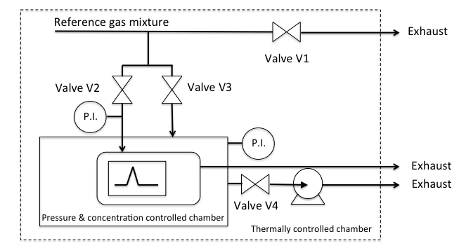
Figure 2. Schematic of the set-up used in the second set of experiments. The chromatograph is surrounded by the reference gas mixture at the calibration pressure. P.I. stands for pressure indicator.

2.2. Experimental procedures
2.2.1 Calibration
When the analysers are in sampling mode, a constant volume of sample containing an unknown mass of benzene is taken. The sample is then subjected to chromatographic separation by a capillary column to discriminate benzene from other components. Subsequently, the mass of benzene is ionised and an electric current proportional to the benzene mass – represented by a peak area – is produced. The relationship between mass and peak area can also be established between the concentration of benzene in the sample and the peak area, provided that temperature and pressure conditions remain constant. For all the calibrations performed, the sample temperature and the temperature of the air surrounding the analyser was set to 293 ± 1 K. The sample pressure at calibration was set to 101.3 ± 0.2 kPa.
The analysers used in this work have three different calibration options: firstly, a linear calibration using a least squares regression; secondly, a calibration line forced through the origin; and finally, a non-linear regression. All three calibration options were tested with eight different mixtures of benzene in air with concentrations ranging from 0.0 to 47.2 µg/m³ (0.0, 0.65, 2.60, 5.20, 10.4, 15.6, 26.3, 36.7 and 47.2 µg/m³). Thus, three calibration curves were obtained and the squared sum of residuals of the concentration tested was obtained for each calibration. The lowest sum of squares (1.16) was obtained with the non-linear (quadratic) calibration, followed by the least squares regression (1.66) and the linear regression forced through the origin (1.78). Therefore, the quadratic option was chosen every time the analysers were calibrated.

2.2.2 Theoretical study of the effect of sample pressure changes on the analysers
Once a BTEX on-site analyser is calibrated at a certain sample pressure and temperature (ideally at 293 K and 101.3 kPa to be at the same conditions as the limit values in the legislation [EC Directive, 2008]), the calibration curve can be used in order to determine the ambient concentrations of BTEX that are at the same conditions as the calibration standards. If sample pressure and/or temperature are different from those at the calibration moment, correction of the readings should be done in order to obtain the measured concentration at the calibration/reference conditions. This is pivotal to be able to compare the readings of the analysers with the limit values. This correction, if not automatically done by the analysers, can be performed by the user using the perfect gas law:
(1)
where C_{a} is the ambient concentration obtained by the analyser when the sample is at pressure P_{sample} and temperature T_{sample}, and C_{a,ref} is the same concentration referred to the reference conditions P_{ref} (101.3 kPa) and T_{ref} (293 K).
Supposing a sample temperature equal to the reference temperature and a sample pressure of 110 kPa, for an ambient concentration of 5.00 µg/m³ (expressed at 101.3 kPa and 293 K) the reading of the analyser – calibrated at the reference pressure – should be C_{a} = 5.00 (110/101.3) = 5.43 µg/m³, which means 0.99% of variation in the readings per kPa, according to the perfect gas law and provided no automatic corrections are performed.

2.2.3 Design of experiments to study the influence of pressure on the analyser readings
2.2.3.1. First set of experiments
A first set of experiments was conducted following the guidelines established in the EN standard 14662-3:2015 regarding variations of pressure, after calibration of the analysers according to section 2.2.1.
The nominal concentration of benzene used in these tests was 5.00 µg/m³, which is the annual limit value of benzene for the protection of human health (EC Directive, 2008). The pressure corrector of the analysers was set on at the beginning of the tests. The sample was set at the reference pressure (101.3 kPa) at the inlet of the analysers. Four individual measurements were taken under these conditions. Subsequently, the absolute sample pressure was reduced to 80 kPa and, again, four individual measurements were taken. Pressure was then set back to 101.3 kPa to check the absence of any drift in the analyser readings. Following this, the sample pressure at the inlet of the analysers was set to 110 kPa and four measurements were taken under the new conditions. Finally, pressure was set back to 101.3 kPa to check that readings at the calibration pressure were the same as the ones at the beginning of the experiment.
In order to achieve a pressure lower than the atmospheric one (80 kPa), valve V1 was fully opened and valve V2 was partially closed. For the inlet pressure higher than the atmospheric one, the status of the valves was the other way round, that is, valve V2 was fully opened and V1 was partially closed.

2.2.3.2. Second set of experiments
Given the results obtained when carrying out the tests described in section 2.2.3.1, a new set of tests was designed, which included testing of more inlet pressures and concentrations, and the use of a stainless steel chamber in which the analysers were placed (Figure 2). This chamber allowed control of the concentration of the air surrounding the analysers as well as its pressure. The procedure followed in this set of tests was:
- Calibrating the analysers according to section 2.2.1.
- Setting on the pressure corrector of the analysers (according to the manufacturer, the correction works fine for pressures ranging from 90 to 105 kPa).
- Generating a reference gas mixture of 5 µg/m³ nominal concentration of benzene in air at 293 ± 1 K and 101.3 ± 0.2 kPa.
- Obtaining six measurements of the previous mixture at each of the following inlet pressures: 80, 90, 101.3, 105 and 110 kPa. Valves V1 and V2 in Figure 2 were operated similarly to the previous tests to achieve the corresponding test pressure. In this case, two additional valves (V3 and V4) and a vacuum pump (P1) were required to get a pressure equal to the atmospheric one inside the stainless steel chamber.
- In all these tests, the stainless steel chamber received the reference gas mixture and the inside pressure was kept at 101.3 ± 0.2 kPa. The rationale for this will be explained in the results section.
- The steps above were also repeated with a reference gas mixture of 40 µg/m³ nominal concentration of benzene in air in order to study the performance of the analysers at different concentration levels.

3. Results and discussion
3.1 Results of the first set of experiments
Figure 3 shows the results obtained when both analysers were subjected to the first set of experiments. It can be observed that when the pressure was equal to the reference pressure during calibration (101.3 kPa) the readings of both chromatographs are on the horizontal line that shows the reference concentration fed to the analysers. When the pressure was around 110 kPa, both analysers gave a higher response than the one expected (12.9% and 8.5% bias, respectively). On the contrary, when the sample pressure was around 80 kPa, both chromatographs produced lower readings than the reference one (93% and 65% bias, respectively).
Both chromatographs were set with the pressure correctors on; however, it is worth noting that the range of operation of these goes from 90 to 105 kPa, according to the manufacturer. This could be one of the reasons why the readings did not correspond to the real concentration introduced to the analysers at the reference conditions. However, the steep decrease in readings when working at 80 kPa was indicative of an additional problem in the performance of the analysers, not only the wrong behaviour of the pressure compensator, especially when working at low pressure. The hypothesis of the analysers taking air from the lab in addition to the gas taken through the inlet port was tested in a second set of experiments (Section 3.2), in which pressures of 90 and 105 kPa were also tested.

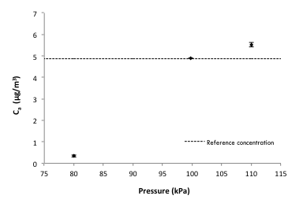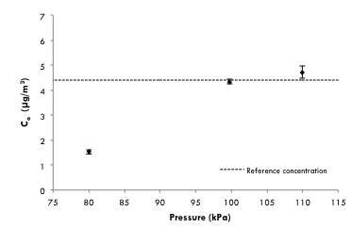
a) b)
Figure 3. Concentration measured by the two chromatographs as a function of the sample pressure for a constant inlet reference concentration of (a) 4.87 µg/m³ for analyser I and (b) 4.40 µg/m³ for analyser II, at 293 K and 101.3 kPa. Error bars represent the standard deviation of four readings.

3.2 Results of the second set of experiments
In order to test the tightness of the chromatographs, a stainless steel chamber was built and the analyser tested was placed in it. The chamber received the same reference mixture as the analyser tested, by means of valve V1 (Figure 2). There was also an exhaust valve (V3) connected to a vacuum pump that prevented the chamber from overpressurising. The pressure in the chamber was set in every test at 101.3 kPa. This pressure ensured that no air from outside the chamber came inside (as in all the tests the atmospheric pressure was slightly lower than the normal atmospheric pressure). In this way, the air surrounding the analyser had the same concentration as the reference mixture measured by the analyser at the reference pressure.
The results obtained in this set of experiments following the procedure detailed in section 2.2.3.2 are shown in Figures 4 and 5. Figure 4 was obtained when measuring a reference gas mixture of 5 µg/m³ benzene in nitrogen with analysers I and II, whereas Figure 5 was obtained with a reference mixture of 40 µg/m³.

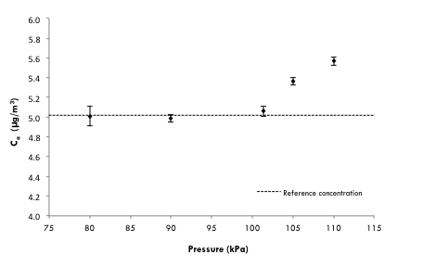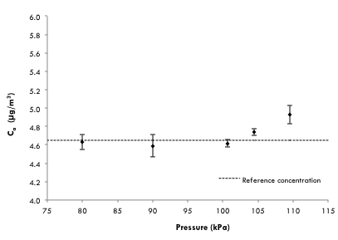
a) b)
Figure 4. Concentration measured by the two chromatographs as a function of the sample pressure when using the stainless steel chamber to control the concentration and pressure surrounding the analysers, for a constant inlet reference concentration of (a) 5.02 µg/m³ for analyser I and (b) 4.65 µg/m³ for analyser II, at 293 K and 101.3 kPa. Error bars represent the standard deviation of six readings.

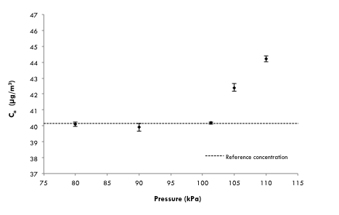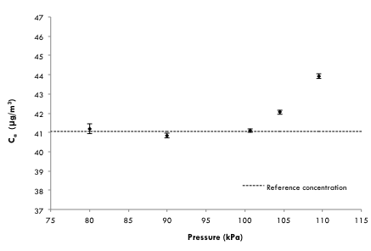
a) b)
Figure 5. Concentration measured by the two chromatographs as a function of the sample pressure when using the stainless steel chamber to control the concentration and pressure surrounding the analysers, for a constant inlet reference concentration of (a) 40.2 µg/m³ for analyser I and (b) 41.1 µg/m³ for analyser II, at 293 K and 101.3 kPa. Error bars represent the standard deviation of six readings.

Interesting conclusions can be drawn from the results obtained. When the sample pressure was higher than the calibration one (101.3 kPa), there was a proportionality between readings and inlet pressure that meets the ideal gas law. According to equation (1), for a reference concentration of 4.62 µg/m³ measured at 101.3 kPa (analyser II), measurements carried out at 105 kPa should produce a result around 4.78 µg/m³. An average reading of 4.74 µg/m³ was obtained, which is fairly close to the theoretically estimated one. For an inlet pressure of 110 kPa, the expected reading is 5.02 µg/m³ and the experimentally obtained one was 4.93 µg/m³, which is in good agreement with the former. For analyser I, the same behaviour was observed, as well as with the results obtained when using a reference concentration of benzene of around 40 µg/m³. All of this clearly indicates that the pressure corrector of the analysers was not working properly and a posteriori correction of the data should be performed in order to obtain valid results.
When the sample pressure was lower than the calibration one, results were similar to the ones obtained at the calibration pressure. This proves that in these cases the sample was not only being taken through the sample port but also through unidentified inlets of the system. The pressure of the air taken through these inlets is the calibration one and its concentration is also the reference one. The flow rate through these unidentified inlets seems to be much higher than the one through the inlet port, as the decrease in readings when the chamber was not used is much more important than expected applying the ideal gas law (Figure 3). This is due to the fact that the analyser was mainly sampling laboratory air whose benzene concentration was very low (< 0.1 µg/m³). On the contrary, when using the chamber, the readings obtained were the correct ones as they were taken at the reference pressure and concentration.
These findings could have an impact on routine measurements as, usually, calibration is performed at a pressure slightly above the atmospheric one and measurements from ambient air are performed at a lower pressure. Thus, chromatographs may be mainly sampling indoor air from the monitoring station and not from outside, with the resulting bias in measurements. Therefore, it is advisable that users of this type of equipment check whether the same behaviour as the one described here is also observed. Sample pressure measurement and control should be implemented in monitoring stations, as large biases could be systematically obtained. Manufacturers, users and third parties that take part in maintenance activities of this type of equipment should make an effort to improve and/or check the hermeticism of the instruments. It is also advisable to improve the algorithms that correct readings by effect of sample pressure.

4. Conclusions
In this paper, the influence of sample pressure on benzene measurements obtained with two in situ BTEX chromatographs has been studied. Changes of sample pressure relative to that in the moment of calibration can easily occur due to the different conditions of the analysers when sampling ambient air, generally through a manifold (underpressurised sample), from the ones when in calibration mode, usually sampling from a gas cylinder (overpressurised sample). The results show that the pressure compensator of the analysers does not perform correctly and, when the sample pressure is lower than the atmospheric one the analysers take air from one or several unidentified inlets apart from the sampling port. Given that the analysers are located indoors, this air can substantially differ from that outdoors. These findings highlight the need for sample pressure measurement and control in air monitoring stations in order to obtain data with lower uncertainties. Manufacturers, users and third parties that take part in maintenance activities of this type of equipment should make an effort to improve and/or check the hermeticism of the instruments. It is also advisable to improve the algorithms that correct readings by effect of sample pressure. Given that the differences in readings when the sampling pressure is lower than the ambient one are due to the dilution of the sample with cleaner air, this effect is likely to be expected also in toluene, ethylbenzene and xylene measurements obtained with this type of analytical technique.
Acknowledgements
We would like to acknowledge the Consejería de Agua, Agricultura y Medio Ambiente of the Comunidad Autónoma de la Región de Murcia for its financial support and for the facilities to carry out this work.

References
Andreoli R., Spatari G, Pigini D, Poli D, Banda I, Goldoni M, Riccelli M, Petyx M, Protano C, Vitali M, Barbaro M, Mutti A (2015) Urinary biomarkers of exposure and of oxidative damage in children exposed to low airborne concentrations of benzene. Environmental Research 142:264-272.
Bahadar H, Mostafalou S, Abdollahi M (2014) Current understandings and perspectives on non-cancer health effects of benzene: a global concern. Toxicology and Applied Pharmacology 276:83–94.
Darrall KG, Figgins JA, Brown RD, Phillips GF (1998) Determination of benzene and associated volatile compounds in mainstream cigarette smoke. Analyst 123:1095-101.
Doval Miñarro M, Ferradás E, Romero Trigueros C, Barberá Rico J (2011) Do pressure changes have an influence on ambient air chemiluminescence NO_{x} measurements? Atmospheric Environment 45:5366–5375.
Baker AK, Beyersdorf AJ, Doezema LA, Katzenstein A, Meinardi S, Simpson IJ, Blake DR, Rowland FS (2008) Measurements of non-methane hydrocarbons in 28 United States cities. Atmospheric Environment 42:170-182.
Bono R, Scursatone E, Schiliro T, Gilli G (2003) Ambient air levels and occupational exposure to benzene, toluene, and xylenes in northwestern Italy. Journal of Toxicology and Environmental Health – Part A 66:519-531.
EC Directive (2008) Council Directive 2008/50/EC on ambient air and cleaner air for Europe. Official Journal of the European Communities L151:1–44.
EN 14662-1 (2005) Ambient air quality. Standard method for measurement of benzene concentrations. Part 1: Pumped sampling followed by thermal desorption and gas chromatography.
EN 14662-2 (2005) Ambient air quality. Standard method for measurement of benzene concentrations. Part 2: Pumped sampling followed by solvent desorption and gas chromatography.
EN 14662-3 (2005) Ambient air quality. Standard method for measurement of benzene concentrations. Part 3: Automated pumped sampling with in situ gas chromatography.
Fernández-Somoano A, Estarlich M, Ballester F, Fernández-Patier R, Aguirre-Alfaro A, Herce-Garraleta MD, Tardon A (2011) Outdoor NO₂ and benzene exposure in the INMA (Environment and Childhood) Asturias cohort (Spain). Atmospheric Environment 45:5240-5246.
Ferradás EG, Doval Miñarro M, Morales Terrés IM, Marzal Martinez FJ (2010) An approach for determining air pollution monitoring sites. Atmospheric Environment 44:2640-2645.
Jaimes-Palomera M, Retama A, Elias-Castro G, Neria-Hernández A, Rivera-Hernández O, Velasco E (2016) Non-methane hydrocarbons in the atmosphere of Mexico City: Results of the 2012 ozone-season campaign. Atmospheric Environment 132:258-275.
Ho CK, Itamura MT, Kelley M, Hughes RC (2001) Review of chemical sensors for in situ monitoring of volatile contaminants. Report SAND2001-0643. Sandia National Laboratories, Albuquerque, New Mexico.
Kotiaho T (1996) On-site environmental and in situ process analysis by mass spectrometry. Journal of Mass Spectrometry, 31:1–15.
Palmgren F, Berkowicz R, Ziv A, Hertel O (1999) Actual car fleet emissions estimated from urban air quality measurements and street pollution models. Science of the Total Environment 235:101–109.
Parra MA, Elustondo D, Bermejo R, Santamaria JM (2009) Ambient air levels of volatile organic compounds (VOC) and nitrogen dioxide (NO₂) in a medium size city in Northern Spain. Science of the Total Environment 407:999–1009.
Savitz DA, Andrews KW (1997) Review of epidemiologic evidence on benzene and lymphatic and hematopoietic cancers. American Journal of Industrial Medicine 31:287–295.
Villanueva F, Notario A, Mabilia R, Albadalejo J, Cabanas B, Martínez E (2012) Intercomparison of tropospheric O₃, benzene and toluene measured by a commercial DOAS system and conventional monitoring techniques. Fresenius Environmental Bulletin 21:4040–4050.
Wang FJ, Costabile F, Liu FL, Hong WM, Fang D, Allegrini, I (2010) Ambient BTX measurements in Suzhou, China. Environmental Monitoring and Assessment 168:21–31.
Wideqvist U, Vesely V, Johansson C, Potter A, Brorstrom-Lunden E, Sjoberg K, Jonsson T (2003) Comparison of measurements methods for benzene and toluene. Atmospheric Environment 37:1963–1973.

