Habitat use and trapping efficiency of the invasive blue crab in shallow waters of a hypersaline coastal lagoon (Western Mediterranean)

Antonio A. Herrero-Reyes^{1*}, Adrián Guerrero-Gómez¹, Antonio Zamora-López¹, Mar Torralva¹, José M. Zamora-Marín^{2,1} & Francisco J. Oliva-Paterna¹

¹Department of Zoology and Physical Anthropology, Faculty of Biology, University of Murcia, CEIR Campus Mare Nostrum (CMN), Murcia, Spain
²Department of Applied Biology, Centro de Investigación e Innovación Agroalimentaria (CIAGRO-UMH), Miguel Hernández University of Elche, Elche, Spain
*Corresponding author: Department of Zoology and Physical Anthropology, Faculty of Biology, University of Murcia, 30100 Murcia, Spain. Email address: antonioandres.herreror@um.es (Antonio A. Herrero-Reyes)

Supplementary material

Table S1. Construction of the models elaborated to show the effects of habitat type, sex, size class, trap type and environmental variables on Atlantic blue crab (Callinectes sapidus) captures in the Mar Menor coastal lagoon (SE Spain). The category and structure of the model is shown, along with the associated label and hypothesis.

Model category | Label | Model structure | Hypothesis
Size ~ Habitat * Catchability | Size_M1_1 | Sampling period * Month + Sampling period * Size category + Month * Size category + Type of trap + Habitat + Dissolved oxygen + Temperature + Salinity + Depth + Muds percentage + Meadow cover (by = habitat) | Size-independent habitat selection  Size-independent catchability
Size ~ Habitat * Catchability | Size_M1_2 | Sampling period * Month + Sampling period * Size category + Month * Size category + Type of trap*Size category + Habitat + Dissolved oxygen + Temperature + Salinity + Depth + Muds percentage + Meadow cover (by = habitat) | Size-independent habitat selection  Size-dependent catchability
Size ~ Habitat * Catchability | Size_M2_1 | Sampling period * Month + Sampling period * Size category + Month * Size category + Type of trap + Habitat * Size category + Dissolved oxygen + Temperature + Salinity + Depth + Muds percentage + Meadow cover (by = habitat) | Size-dependent habitat selection  Size-independent catchability
Size ~ Habitat * Catchability | Size_M2_2 | Sampling period * Month + Sampling period * Size category + Month * Size category + Type of trap * Size category + Habitat * Size category + Dissolved oxygen + Temperature + Salinity + Depth + Muds percentage + Meadow cover (by = habitat) | Size-dependent habitat selection  Size-dependent catchability
Sex ~ Sector * Catchability | Sex_M1_1 | Sampling period * Month + Sampling period + Month + Sex + Type of trap + Sector + Habitat | Sex-independent Sea influence selection  Sex-independent catchability
Sex ~ Sector * Catchability | Sex_M1_2 | Sampling period * Month + Sampling period + Month + Type of trap * Sex + Sector + Habitat | Sex-independent Sea influence selection  Sex-dependent catchability
Sex ~ Sector * Catchability | Sex_M2_1 | Sampling period * Month + Sampling period + Month + Type of trap + Sector * Sex + Habitat | Sex-dependent Sea influence selection  Sex-independent catchability
Sex ~ Sector * Catchability | Sex_M2_2 | Sampling period * Month + Sampling period + Month + Type of trap * Sex + Sector * Sex + Habitat | Sex-dependent Sea influence selection  Sex-dependent catchability
Sex ~ Habitat * Catchability | Sex_M3_1 | Sampling period * Month + Sampling period * Sex + Month * Sex + Type of trap + Habitat + Dissolved oxygen + Temperature + Salinity + Depth + Muds percentage + Meadow cover (by = habitat) | Sex-independent habitat selection  Sex-independent catchability
Sex ~ Habitat * Catchability | Sex_M3_2 | Sampling period * Month + Sampling period * Sex + Month * Sex + Type of trap * Sex + Habitat + Dissolved oxygen + Temperature + Salinity + Depth + Muds percentage + Meadow cover (by = habitat) | Sex-independent habitat selection  Sex-dependent catchability
Sex ~ Habitat * Catchability | Sex_M4_1 | Sampling period * Month + Sampling period * Sex + Month * Sex + Type of trap + Habitat * Sex + Dissolved oxygen + Temperature + Salinity + Depth + Muds percentage + Meadow cover (by = habitat) | Sex-dependent habitat selection  Sex-independent catchability
Sex ~ Habitat * Catchability | Sex_M4_2 | Sampling period * Month + Sampling period * Sex + Month * Sex + Type of trap * Sex + Habitat * Sex + Dissolved oxygen + Temperature + Salinity + Depth + Muds percentage + Meadow cover (by = habitat) | Sex-dependent habitat selection  Sex-dependent catchability

Table S2. List of animal species and taxonomic correspondence recorded during crab sampling in each of the study sectors: Mar Menor (MM) or Mediterranean (MED). The number of species per taxa (N) is also provided.

Species (macrofauna) | N | Sampling sector
CRUSTACEANS
Callinectes sapidus Rathbun, 1896 | 538 | MM, MED
Carcinus aestuarii Nardo, 1847 | 153 | MM, MED
Hermit crab (unidentified) | 47 | MED
Macropodia rostrata (Linnaeus, 1761) | 1 | MED
Palaemon elegans Rathke, 1836 | 812 | MM,MED
Penaeus kerathurus (Forskål, 1775) | 10 | MM,MED
OTHER INVERTEBRATES
Hexaplex trunculus (Linnaeus, 1758) | 87 | MM,MED
Starfish (unidentified) | 1 | MED
FISHES
Anguilla anguilla (Linnaeus, 1758) | 9 | MM, MED
Apricaphanius iberus (Valenciennes, 1846) | 2 | MM
Atherina boyeri Risso, 1810 | 1 | MM
Chelon saliens (Risso, 1810) | 1 | MM
Chelon sp. | 2 | MM
Dicentrarchus labrax (Linnaeus, 1758) | 4 | MM,MED
Diplodus annularis (Linnaeus, 1758) | 5 | MED
Gobius niger Linnaeus, 1758 | 128 | MM,MED
Gobius paganellus (Linnaeus, 1758) | 12 | MM,MED
Lithognathus mormyrus (Linnaeus, 1758) | 2 | MM,MED
Millerigobius macrocephalus (Kolombatovic, 1891) | 1 | MED
Mullus barbatus Linnaeus, 1758 | 14 | MED
Pachygrapsus marmoratus (Fabricius, 1787) | 5 | MM,MED
Parablennius sanguinolentus (Pallas, 1814) | 1 | MM,MED
Salaria pavo (Risso, 1810) | 59 | MM,MED
Sarpa salpa (Linnaeus, 1758) | 1 | MED
Scorpaena sp. | 1 | MED
Sepia officinalis Linnaeus, 1758 | 2 | MED
Serranus scriba (Linnaeus, 1758) | 2 | MED
Solea sp. | 2 | MM
Sparus aurata Linnaeus, 1758 | 52 | MM,MED
Symphodus cinereus (Bonnaterre, 1788) | 25 | MM,MED
Symphodus ocellatus (Linnaeus, 1758) | 1 | MED

Table S3. Summary table showing the best hypothesis for each fitted model studied in bold (see Table S1). Best hypothesis was chosen according to its Akaike information criterion (AICc) and the deviance explained.

Model category | Label | Hypothesis | AICc | Deviance explained
Size ~ Habitat * Catchability | Size_M1_1 | Size-independent habitat selection  Size-independent trapping effectiveness | 1663.7 | 51.9
Size ~ Habitat * Catchability | Size_M1_2 | Size-independent habitat selection  Size-dependent trapping effectiveness | 1631 | 54.8
Size ~ Habitat * Catchability | Size_M2_1 | Size-dependent habitat selection  Size-imdependent trapping effectiveness | 1610 | 58.3
Size ~ Habitat * Catchability | Size_M2_2 | Size-dependent habitat selection  Size-dependent trapping effectiveness | 1578.6 | 60.5
Sex ~ Sector * Catchability | Sex_M1_1 | Sex-independent Sea influence selection  Sex-independent trapping effectiveness | 2657.8 | 38.9
Sex ~ Sector * Catchability | Sex_M1_2 | Sex-independent Sea influence selection  Sex-dependent trapping effectiveness | 2656.2 | 39.2
Sex ~ Sector * Catchability | Sex_M2_1 | Sex-dependent Sea influence selection  Sex-independent trapping effectiveness | 2625.2 | 41.3
Sex ~ Sector * Catchability | Sex_M2_2 | Sex-dependent Sea influence selection  Sex-dependent trapping effectiveness | 2624.5 | 41.5
Sex ~ Habitat * Catchability | Sex_M3_1 | Sex-independent habitat selection  Sex-independent trapping effectiveness | 1286.4 | 58
Sex ~ Habitat * Catchability | Sex_M3_2 | Sex-independent habitat selection  Sex-dependent trapping effectiveness | 1281.3 | 58.7
Sex ~ Habitat * Catchability | Sex_M4_1 | Sex-dependent habitat selection  Sex-independent trapping effectiveness | 1290.6 | 58
Sex ~ Habitat * Catchability | Sex_M4_2 | Sex-dependent habitat selection  Sex-dependent trapping effectiveness | 1285.1 | 58.8

Table S4. Summary table of captures and their CW (mm) mean on a spatial-temporal scale. The table is depicting the number of captures of blue crabs (N) and the mean of their carapace width (CW) and the ± the standard deviation (SD) in every month and sector. The spatial approach covers the two study sectors together and separately: Mediterranean (MED) and Mar Menor (MM).

Sampling sector | Month | N | CW mean | ± SD
MM and MED | January | 36 | 111.89 | 23.51
MM and MED | March | 53 | 123.53 | 19.57
MM and MED | May | 60 | 114.38 | 32.45
MM and MED | July | 138 | 95.01 | 23.13
MM and MED | September | 212 | 110.22 | 25.38
MM and MED | November | 39 | 136.33 | 17.13
MM | January | 36 | 111.89 | 23.51
MM | March | 51 | 122.16 | 18.63
MM | May | 59 | 114.31 | 32.72
MM | July | 122 | 91.23 | 21.19
MM | September | 103 | 108.76 | 22.70
MM | November | 37 | 137.92 | 15.07
MED | January | 0 | - | -
MED | March | 2 | 158.50 | 4.95
MED | May | 1 | 119.00 | -
MED | July | 16 | 123.81 | 16.26
MED | September | 109 | 111.61 | 27.71
MED | November | 2 | 107.00 | 33.94

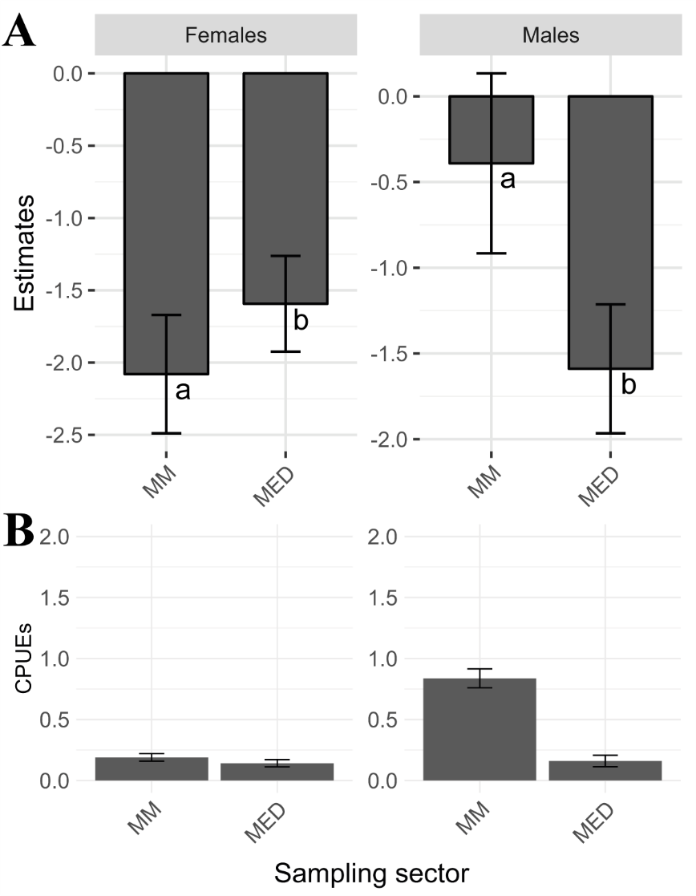

Figure S1. Summary plot of the best sex-sector model (A) and CPUEs at the sector level (B). A Coefficients of the Sex_M2_1 model, the best one relating the sex of the blue crab specimens with the sector where they were caught. Lowercase letters indicate groups resulting from the pairwise test (P ≤ 0.05). B It shows the mean ± standard error of captures per unit effort (CPUEs) of the blue crabs, according to their sex and the sampling sector where they were caught. Both Mar Menor (MM) and Mediterranean (MED) sector are shown separately.

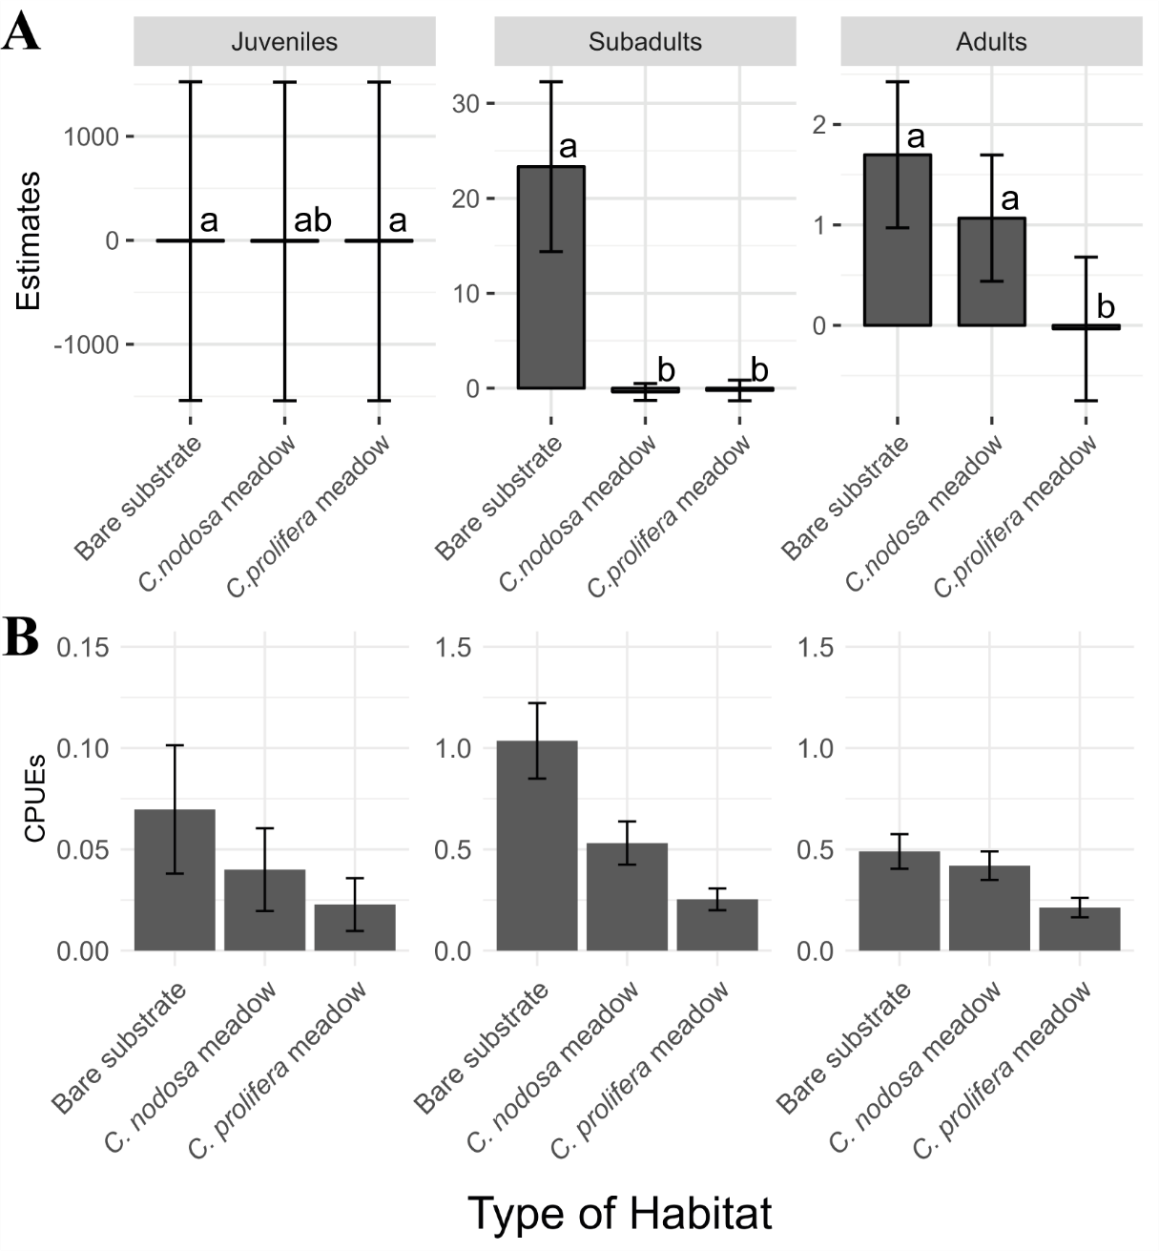

Figure S2. Summary plot of the best size-habitat model (A) and CPUEs by type of habitat (B). A Coefficients of the Size_M2_2 model, the best one relating the three size classes (juvenile, subadult and adult) of the blue crabs specimens with the type of habitat where they were caught. Lowercase letters indicate groups resulting from the pairwise test (P ≤ 0.05). B It shows the mean ± standard error of captures per unit effort (CPUEs) of the blue crabs, according to the type of habitat where they were caught. The three different types of bottom habitat are shown: Cymodocea nodosa meadows, Caulerpa prolifera meadows and bare substrate.

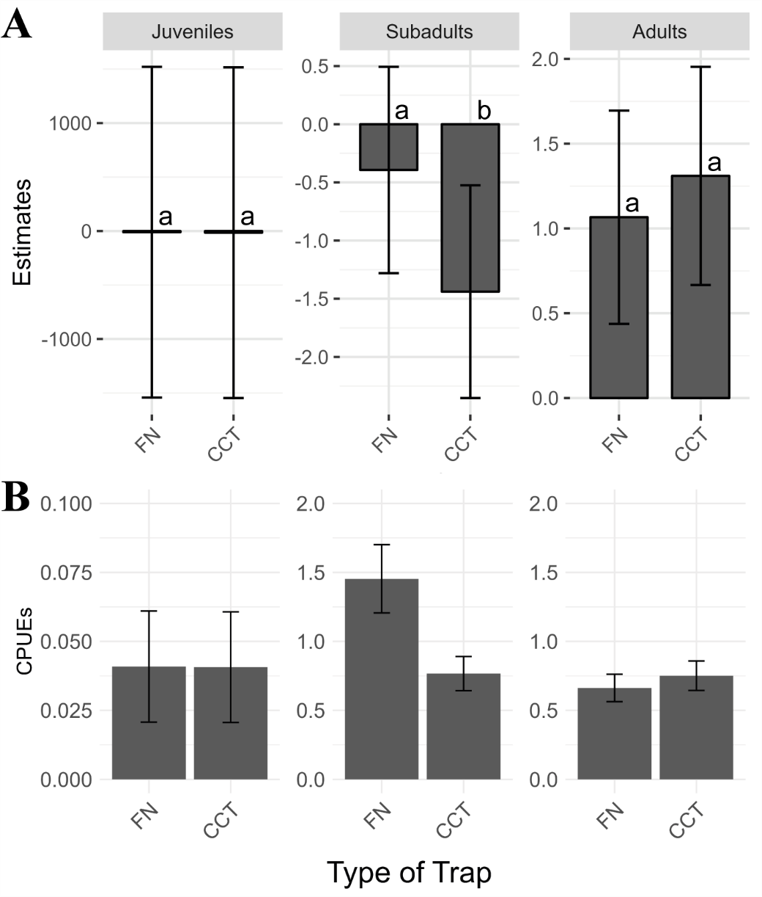

Figure S3. Summary plot of the best size-trap model (A) and CPUEs by type of trap (B). A Coefficients of the Size_M2_2 model, the best one relating the three size classes (juvenile, subadult and adult) of the blue crabs specimens with the type of trap that caught them. Lowercase letters indicate groups resulting from the pairwise test (P ≤ 0.05). B It shows the mean ± standard error of captures per unit effort (CPUEs) of the blue crabs, according to their size class and the type of trap that caught them. Both fyke nets (FN) and collapsible cylindrical traps (CCT) are shown separately.

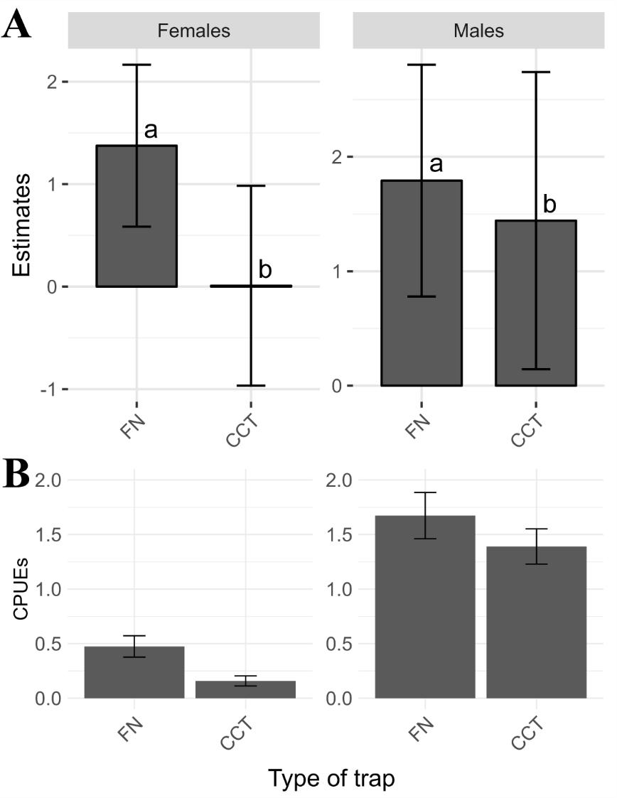

Figure S4. Summary plot of the best sex-trap model (A) and CPUEs by type of trap (B). A Coefficients of the Sex_M3_2 model, the best one relating the sex of the blue crabs specimens with the type of trap that caught them. Lowercase letters indicate groups resulting from the pairwise test (P ≤ 0.05). B It shows the mean ± standard error of captures per unit effort (CPUEs) of the blue crabs, according to their sex and the type of trap and the type of trap that caught them. Two different types of trap are shown: Fyke nets (FN) and collapsible cylindrical traps (CCT).

